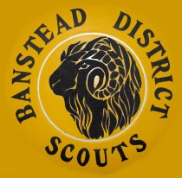

Banstead Scouts History Project

Here are some questions to help you reflect on your time in Banstead Scouting. Please do add anything else.

- Which group were you in and when? Where did you meet?

- What were your leaders called? What memories do you have of them?

- Describe the activities you enjoyed the most.

- Where did you go camping? How did you get there and what did you do?

- Were your friends involved too?

- What was your best Scouting memory?

- Do you have any pictures you could share with us?

- Any other memories you would like to tell us about?

Please email your form to history@bansteadscouts.co.uk

